Future Leaders Challenge East Africa 2025
28–29 April 2025 | Strathmore University, Nairobi, Kenya
Theme: Towards a Sustainable Human Capital Strategy for Hospitality and Tourism in East Africa
Patron: Hon. Rebecca Miano, EGH, Cabinet Secretary for Tourism and Wildlife

Introduction
The inaugural Future Leaders Challenge East Africa 2025 (FLCEA25), held from April 28–29, 2025, at Strathmore University, marked a pivotal moment for regional tourism development. Under the theme “Towards a Sustainable Human Capital Strategy for Hospitality and Tourism in East Africa”, the event convened over 200 participants from Kenya, Tanzania, Uganda, and Rwanda — including students, educators, policymakers, and industry leaders.

A joint initiative by the Global Tourism Resilience and Crisis Management Centre – Eastern Africa (GTRCMC-EA), Kenyatta University, under the Ministry of Tourism and Wildlife, in partnership with the East Africa Future Leaders Challenge, Strathmore University, and Boma College, the event aimed to close the skills gap in hospitality and tourism. It emphasized aligning education with industry demands and fostering long-term, multi-stakeholder collaboration for sustainable sector growth.

Background
With tourism increasingly shaped by digital innovation, sustainability imperatives, and evolving traveler expectations, FLCEA25 addressed the urgent need to re-calibrate human capital strategies. It provided a strategic platform to bridge the gap between academic theory and practical industry requirements, preparing a future-ready workforce.
As part of a global initiative, the event culminated in the selection of three winning institutions that will represent East Africa at the Global Finals in Dubai (2026) — showcasing regional talent and innovation on a global stage.

Key Components
1. Student Challenge
Multidisciplinary student teams developed and pitched solutions to real-world challenges in tourism and hospitality, focusing on:
- Digital transformation
- Sustainability
- Workforce readiness
2. School Directors’ Alliance (SDA) Summit
Key stakeholders from academia, government, and industry met to:
- Strategize on collaborative talent development
- Align curricula with labor market needs
- Explore the policy landscape shaping tourism education

Objectives
- Assess the impact of digital transformation on the tourism and hospitality workforce
- Identify skills gaps and promote curricular reform
- Foster cross-sector collaboration for sustainable development
- Evaluate tourism policies targeting resilience and multi-destination integration

Event Highlights
Welcome Dinner – 27 April 2025
Young changemakers, alongside leaders from academia, policy, and industry, gathered at KICC for a vibrant evening of celebration, connection, and shared purpose. Sponsored by Hon. Rebecca Miano, EGH, the Cabinet Secretary for Tourism and Wildlife and Patron of the GTRCMC-EA, the dinner marked the start of FLCEA25. Representing the CS, Mr. Ngari Gituku delivered her message, highlighting the power of youth in shaping a resilient and dynamic tourism sector: “The future of tourism is bright — and it starts now.”
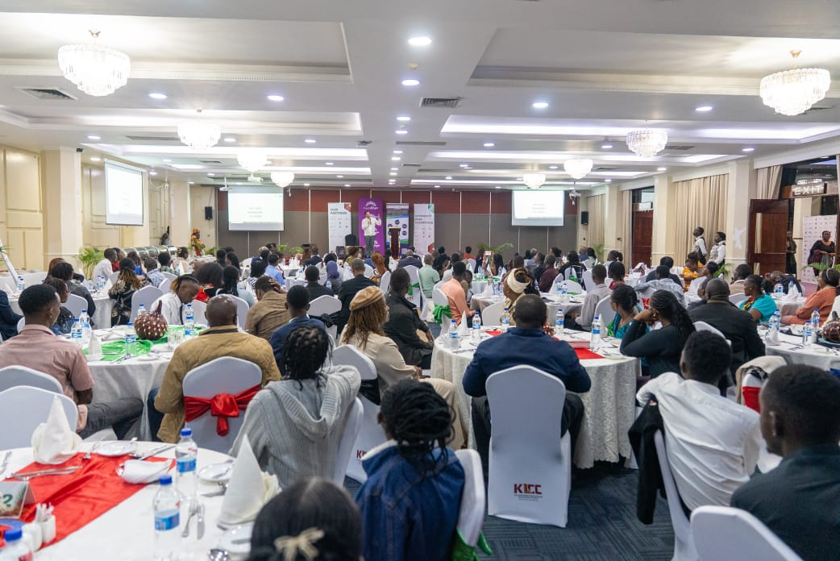

Opening Ceremony – 28 April 2025
Hon. Miano officially opened the conference, at Strathmore University, calling on youth to lead the industry into a tech-driven, sustainable future. She underscored tourism’s contribution to nearly 10% of Kenya’s GDP, while emphasizing the sector’s untapped potential.

Dr. Elizabeth Gachenga, Vice Chancellor of Strathmore University, welcomed participants, reaffirming the university’s commitment to nurturing globally competent leaders in tourism.

Students’ Empowerment Session and SDA Summit – 28 April 2025
The Students’ Empowerment Session focused on inspiring and equipping future leaders by fostering meaningful change and providing them with the tools and resources to realize their full potential. While addressing the students, the EA FLC Patron, Hon. Rebecca Miano, encouraged them to remain resilient by sharing her inspiring career journey.

Held concurrently, the School Directors’ Alliance (SDA) Summit led to the official launch of the School Directors Alliance for East Africa — a unified regional body tasked with leading, coordinating, and advancing sustainable human capital development in the hospitality and tourism sectors.
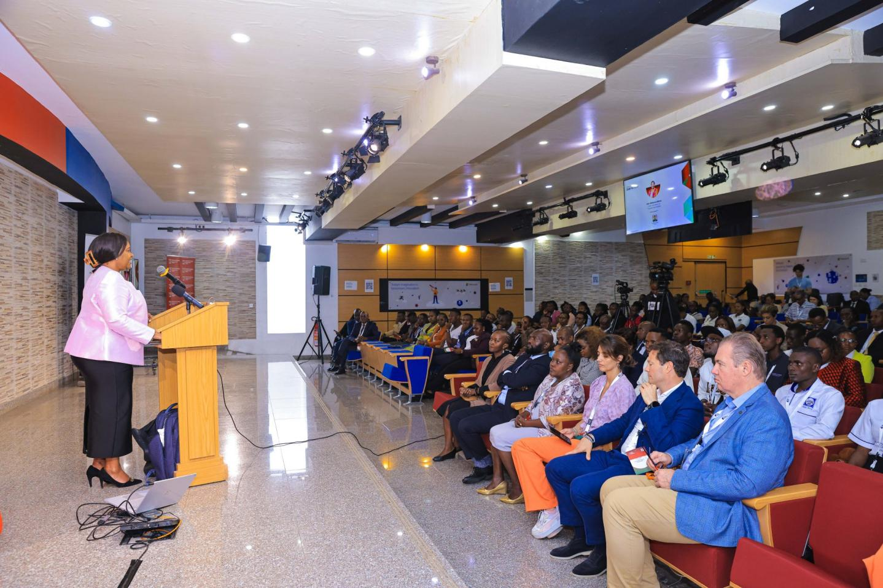
Dinner – 28 April 2025
Held at Mövenpick Hotel Nairobi, this evening brought together students, partners, and leaders for a second night of shared meals and meaningful conversations. Generously sponsored by Vision Linens, the dinner celebrated collaboration and foresight in hospitality development.

Student Challenge – 29 April 2025
Student teams presented bold, forward-thinking solutions. The leading projects were:
- Position one: USIU-Africa – Agile: A digital recruitment platform tailored for hospitality employers.
- Position two: Strathmore University – Savannah Vision: A smart tourism solution using drones, EVs, and holograms to enhance visitor experiences.
- Position three: Technical University of Kenya – Bthere: A real-time mobile app connecting tourists to verified local guides.
These winning ideas demonstrated the students’ ingenuity, feasibility, and alignment with global tourism trends.

Closing Ceremony
Mrs. Doreen Katusiime, Permanent Secretary, Uganda Ministry of Tourism and Antiquities, delivered closing remarks, commending the Challenge for giving young professionals a platform to gain practical experience and international exposure: “As a region, we must continuously build our capacity.”

Expected Outcomes
- A regional human capital strategy for hospitality and tourism
- Stronger alignment between government, academia, and industry
- Enhanced policy frameworks on multi-destination tourism, resilience, and workforce readiness
- A pipeline of skilled youth leaders poised to transform East Africa’s tourism sector

Way forward
- Creation of a Sustainable Human Capital Strategy for Hospitality and Tourism in East Africa, whose key components are as follows:
- Skills Training – Focus on digital, soft, and green skills.
- Industry Linkages – Strengthen internships and mentorships.
- Regional Integration – Harmonize qualifications across East Africa.
- Policy Support – Promote enabling policies for workforce growth.
- Youth Empowerment – Boost youth leadership and entrepreneurship.
- Curriculum Alignment – Update programs to match industry demands.
- Innovation Commercialization – Support student innovations to market.
- School Directors Alliance – Create an East Africa School Directors Alliance to unite institutions for collaboration and advocacy.
- Monitoring & Evaluation – Track outcomes for continuous improvement.

Here is what is ahead on the road to the finals:
- South Africa – May 5–6, 2025 #FLCRSA25
- Morocco – June 2–3, 2025 #FLCMO25
- United Kingdom – June 9–10, 2025 #FLCUK25
- Zimbabwe – August 25–26, 2025 #FLCZI25
- Saudi Arabia – Early October 2025 (dates TBC) #FLCKSA25
- Finals | Dubai – January 2026 #FLCFinals26

Conclusion
The Future Leaders Challenge East Africa 2025 marks the dawn of a transformative regional movement—one rooted in innovation, collaboration, and strategic capacity-building to foster a resilient, future-ready, and inclusive tourism sector. The event effectively laid a strong foundation for harmonizing education, nurturing top-tier talent, and reinforcing supportive policy frameworks to drive sustainable growth in hospitality and tourism.

As East Africa looks ahead to the Global Finals in Dubai 2026, its emerging leaders have already proven their readiness—not merely to take part, but to shape the future of global tourism with confidence and vision.

This landmark event was made possible through the generous support of the Ministry of Tourism and Wildlife, Tourism Fund, Tourism Promotion Fund, Kenya Tourism Board, and other valued partners.

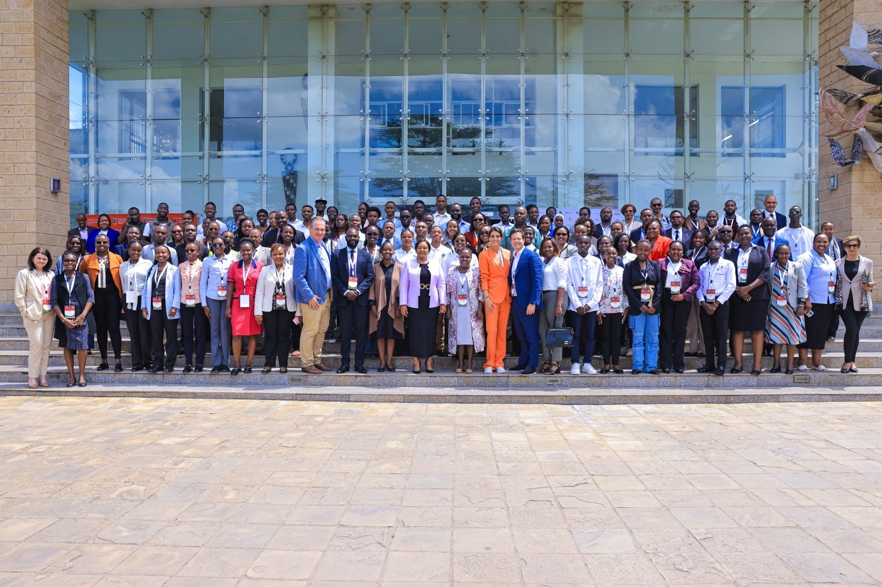

Contact Details
Dr Esther Munyiri
Country Manager, East Africa Future Leaders Challenge and
Director, Global Tourism Resilience and Crisis Management Centre - Eastern Africa
Kenyatta University
Phone: +254721257133
Email: kagure.esther@ku.ac.ke

